# Cloud Computing - what & why:

# Azure Services:

It can be used for creating applications and services, storing data, Hosting websites or blogs, Storing and streaming music / videos, Software on demand, Storing logs and getting visuals to easily use them.

## Compute services

1. **Virtual Machine** - Create window / Linux machine & configure RAM, Hard disk etc Wide range to choose, Easily scalable, Pay for what you use.
2. **Batch**: Work with large number of machines, Manage and schedule it
3. **Cloud Service** - Users can create scalable applications on cloud and post deployment it is managed by Azure. User can write a code without thinking about hardware required
4. **Service Fabric** - Helpful for microservices ( app having smaller apps) - package, manage and deploy & handle workload (dynamically increase the number of machines as when required).
5. **Virtual Machine scale set:** Centrally manage large no. of machines, control workloads based on demand and schedule
6. **Functions** - Create applications in any programming language and azure handles resource management ( just provide code)

## Network Services

1. **CDN** - Content Delivery network - Delivers content to users
2. **Express route** - Private communication
3. **Virtual network** - Communicate azure resources
4. **DNS** - Host application domains

## Storage

1. **Disk Storage** - Cost effective Hard disk and SSD
2. **Blob Storage** - Optimised for massive unstructured data
3. **File storage** - Managed file storage that is accessible via industry protocols
4. **Queue storage** - Provides durable message storage

Microsoft support **SaaS** (Software as a service), **Paas** (Platform as a service), **Ias** ( Infrastructure as a service)

Services by Azure

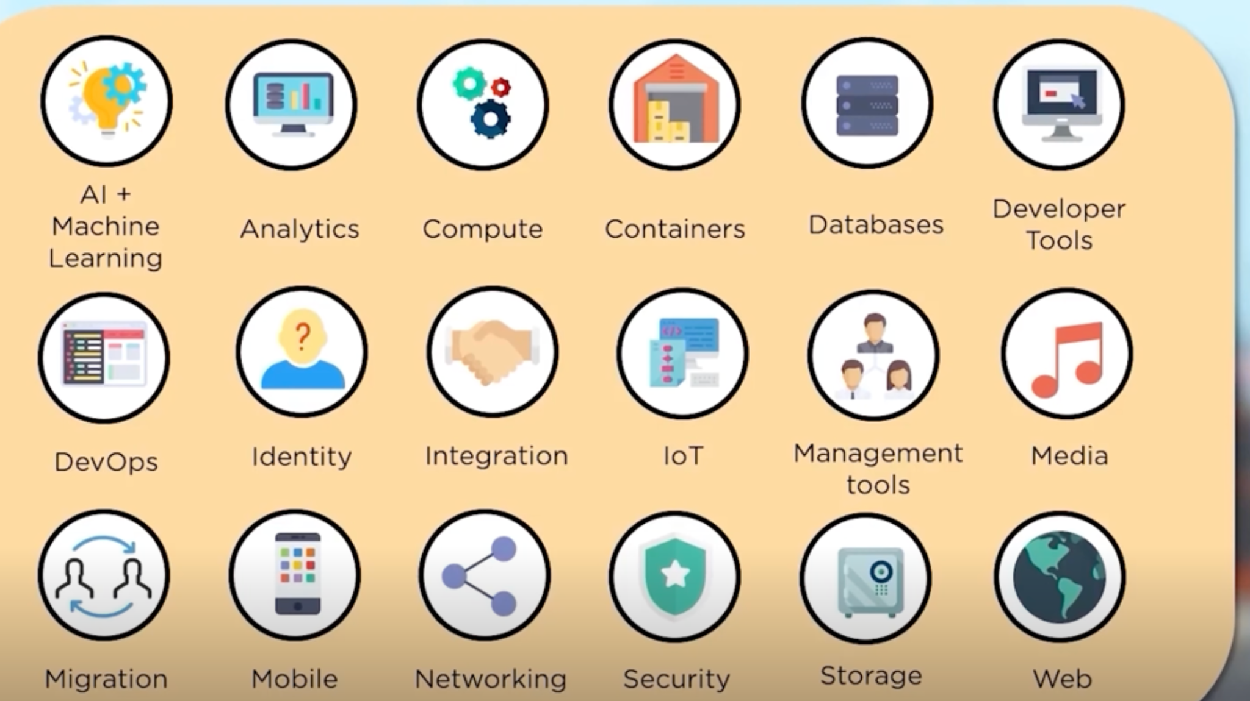

## Container :

Software to package the code with all its dependencies to run from one environment to another.

Quickly deploy production ready

Services in containers are:

1. **Container instance**: Helps a developer to focus only on Application & virtual machines and tools required.
2. **Container service / Kubernetes**: Control and manager operations of container
3. **Container registry**: All the container images are stored and managed from here.

## Azure Databases:

Some of the services are:

1. **SQL Database**: Intelligent relational database service, fully managed. Intelligently learns patterns & optimizes security and performance.
2. **Cosmos DB:** Supports NOSQL for low latency and scalable applications. Users get no of API options
3. **Redis cache:** Used to improve performance, scalability of applications depending on backend data by temporary copying frequently accessed data to fast storage located nearby. With Redis cache, data is stored in memory and not on disk

## Security & Identity:

1. Identity is authentication and authorisation.
2. Azure identity allows authorisation on cloud and in local.

Services under this are

1. **Azure Security center:** Helps in security management and threat protection on cloud and hybrid. Control user access & application control. Helps in finding vulnerabilities. Uses advanced analytics to detect attacks. Provides unified view of security policies across all users on cloud or hybrid
2. **Key vault:** Helps in safeguarding the keys or other secrets used by cloud application and services
3. **Azure Active Directory:** Help in limiting resource usage and managing identities. Core directory + access management + identity protection.

## Management Tools:

Management tools help in monitoring the infrastructure, applications. Provisioning applications, taking backups, building disaster recoveries, monitoring security and cost optimisation.

1. **Azure advisor**: Guides about azure best practices. Recommends based on category of service and tells the impact of recommendation. It is templatised and customized based on usage patterns
2. **Network watcher**: Helps to identify and gain insights on network performance. Insights on network traffic. Generates logs to identify issues with VMs, VPN connectivity issues are easily identified with logs which is complex process otherwise
3. **Microsoft Azure portal:** Helps in building, managing and monitoring web applications. Portal can be organized as per requirement, helps in looking into billing charges.
4. **Azure Resource manager:** Helps in managing resources of an application as a whole including resources used by various components.
5. **Automation:** Gives ability to automate and install updates across hybrid environments. Helps in automating management tasks to reduce costs.

## Networking Tools:

58 mins

## Azure Machine Learning Studio:

We can make pipelines, use built in models, load datasets, make transformation & selections without any code just by drag and drop of modules.

## Azure Active Directory:

Active directory is a cloud based directory & identity service.

Windows active directory is a directory service allowing to work with multiple networks. But it has different layers

1. Windows active directory domain service: Allows admin to manage information about logins
2. Azure data lake storage service: Allows storage of data
3. Active directory federation service: Allows single sign in to access all services
4. Active directory and certification service: customize services to issue public certificates i.e. make it as fit for public
5. Active directory Rights Management Service: Security too for Data protections

Azure converts these all to 2 layers

1. Windows Azure active directory: Combines everything around identity management
2. Windows Azure access control Service

## Azure Data Factory:

It stores data using data lake storage, Analyze it and transform using pipelines & publish it.

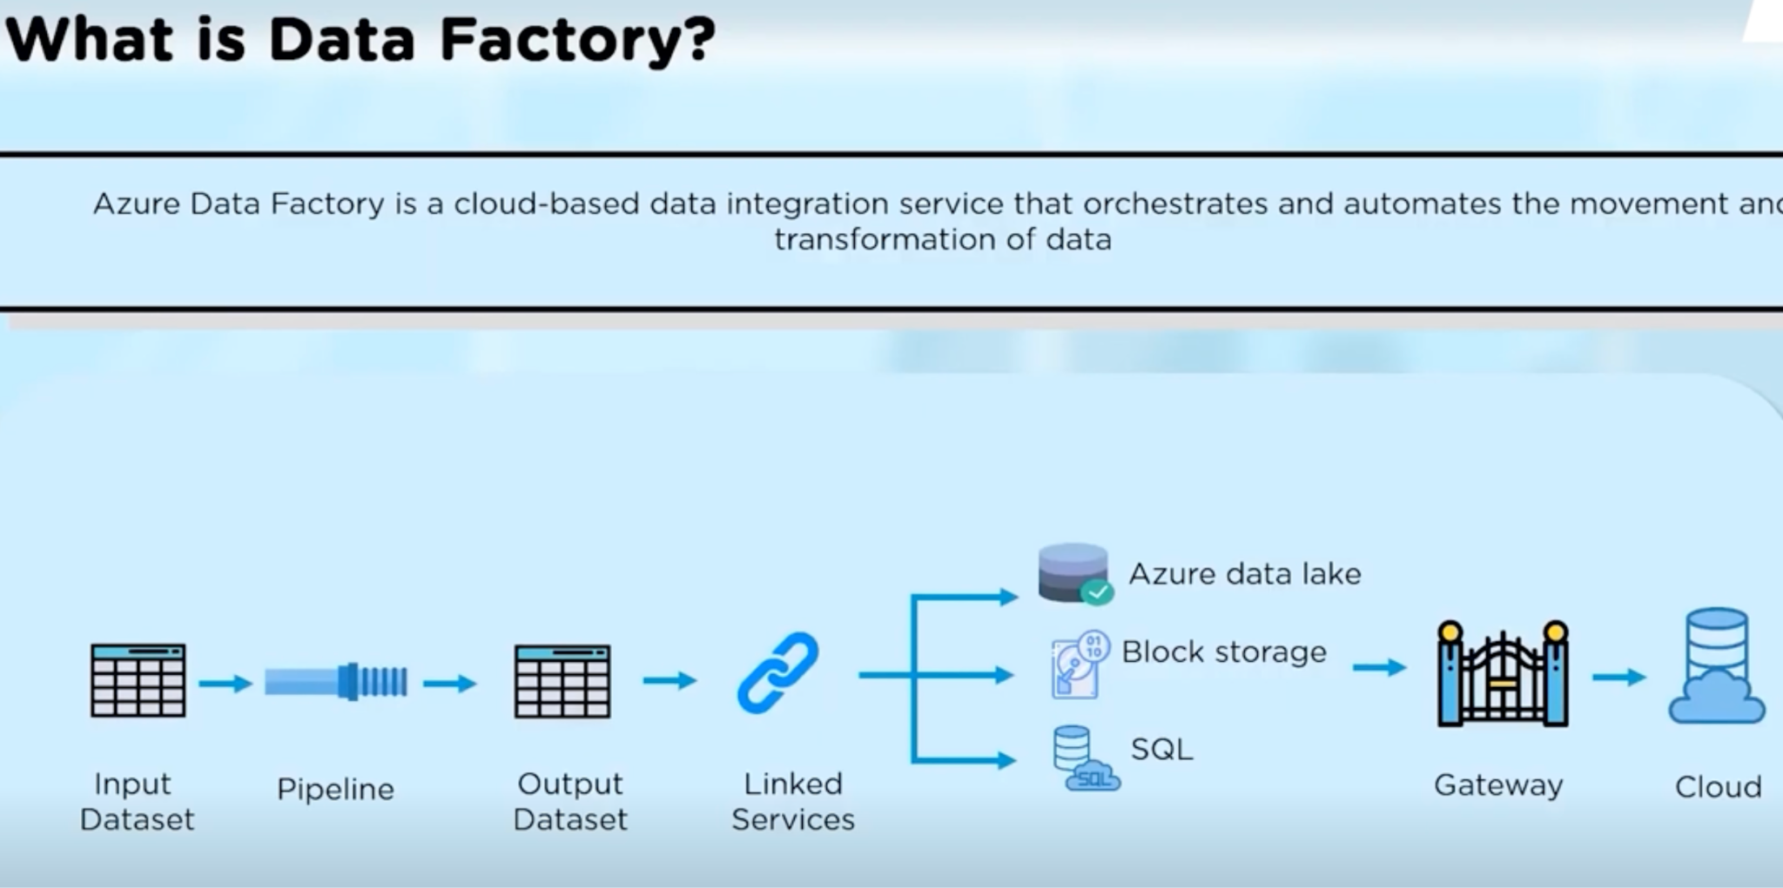

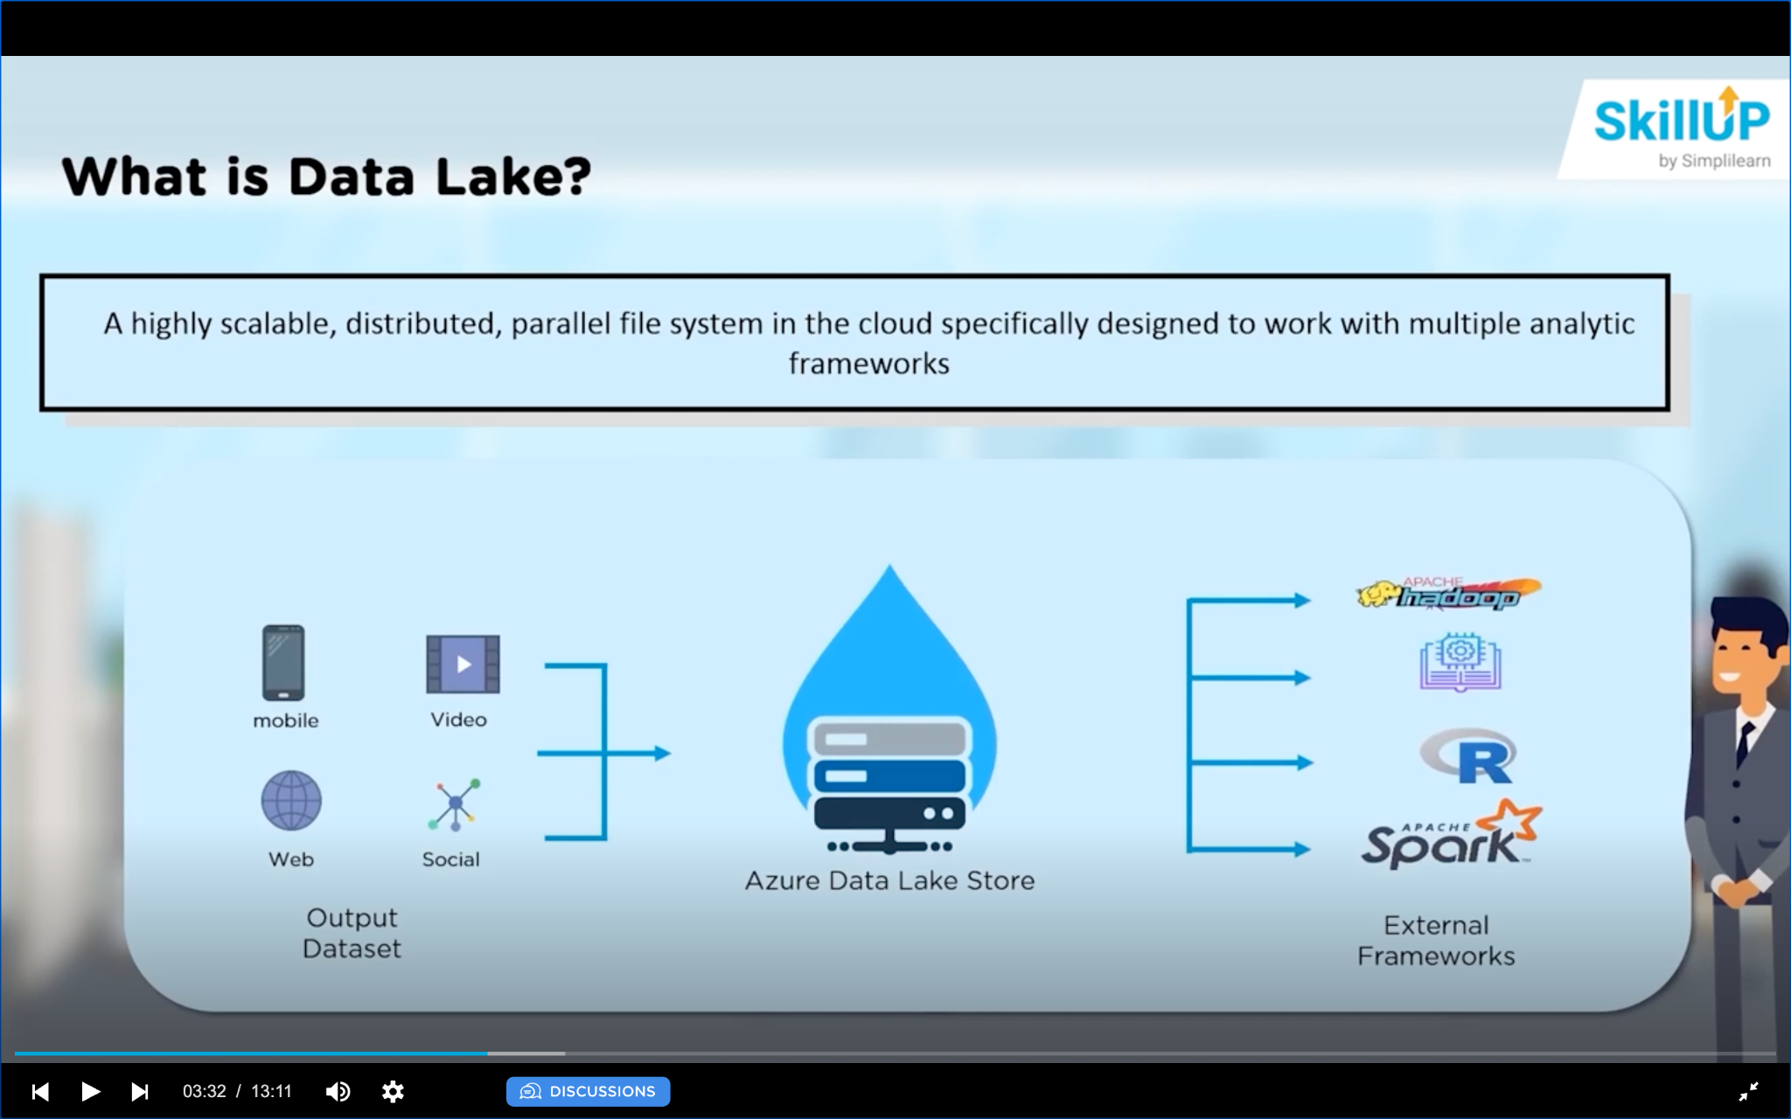

Data lake has storage and analytics. Analytics helps in monitoring the real time data, determine fraudulent activities and so on.